Registrar application requirements
Phillip Calvin

Problem statement
- As a registrar,
- I want to maintain a list of students and information about them
- so that I know authoritatively who attends the institution.

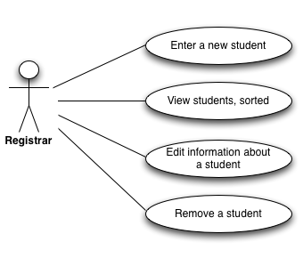

Scenario: Add a new student
- I choose to add a new student.
- I enter the following details about the student:
  - First and last name
  - Address (street, city, and state)
  - Credit hours
  - GPA
  - Level of student (graduate or undergraduate)
- For undergraduate students, I then also enter:
  - the year of the student (typically “freshman”).
- For graduate students, I instead enter:
  - the number of years attended so far
  - the intended degree
- If I failed to specify certain information about the student, I want to be warned and want to be able to correct those entries as needed.
- I confirm that the student information is correct.
- I receive confirmation that the student is now in the system.

Scenario: View all existing students
- I choose to view a list of all students.
- I choose that I want the list to be sorted by one of the following:
  - ID number
  - Last name
  - GPA
  - Credit hours
  - Year
- I see the list of the students presented.

Scenario: Edit an existing student
- If I do not know the student’s ID, I follow the above scenario to find the student by another attribute.
- I choose that I want to edit a student.
- I enter the student’s ID number.
- If the student is not found, I exit the scenario.
- If a student with that ID is found, the attributes of that student are presented.
- I can choose an attribute and enter a new value.
- Once I have edited attributes as necessary, I confirm that the information is correct and should be saved.
- I receive confirmation that the information was saved.

Scenario: Delete an existing student
- I follow steps 1–5 above. In addition to seeing the attributes of the student, I am also presented with an option to delete the student.
- I confirm that the student should be deleted.
- I receive confirmation that the student was deleted.

